Ideation Phase
Define the Problem Statements

Date | 31 January 2025
Team ID | LTVIP2026TMIDS41542
Project Name | ShopSmart:Your Digital Grocery Store Experience
Maximum Marks | 2 Marks

Customer Problem Statement Template:
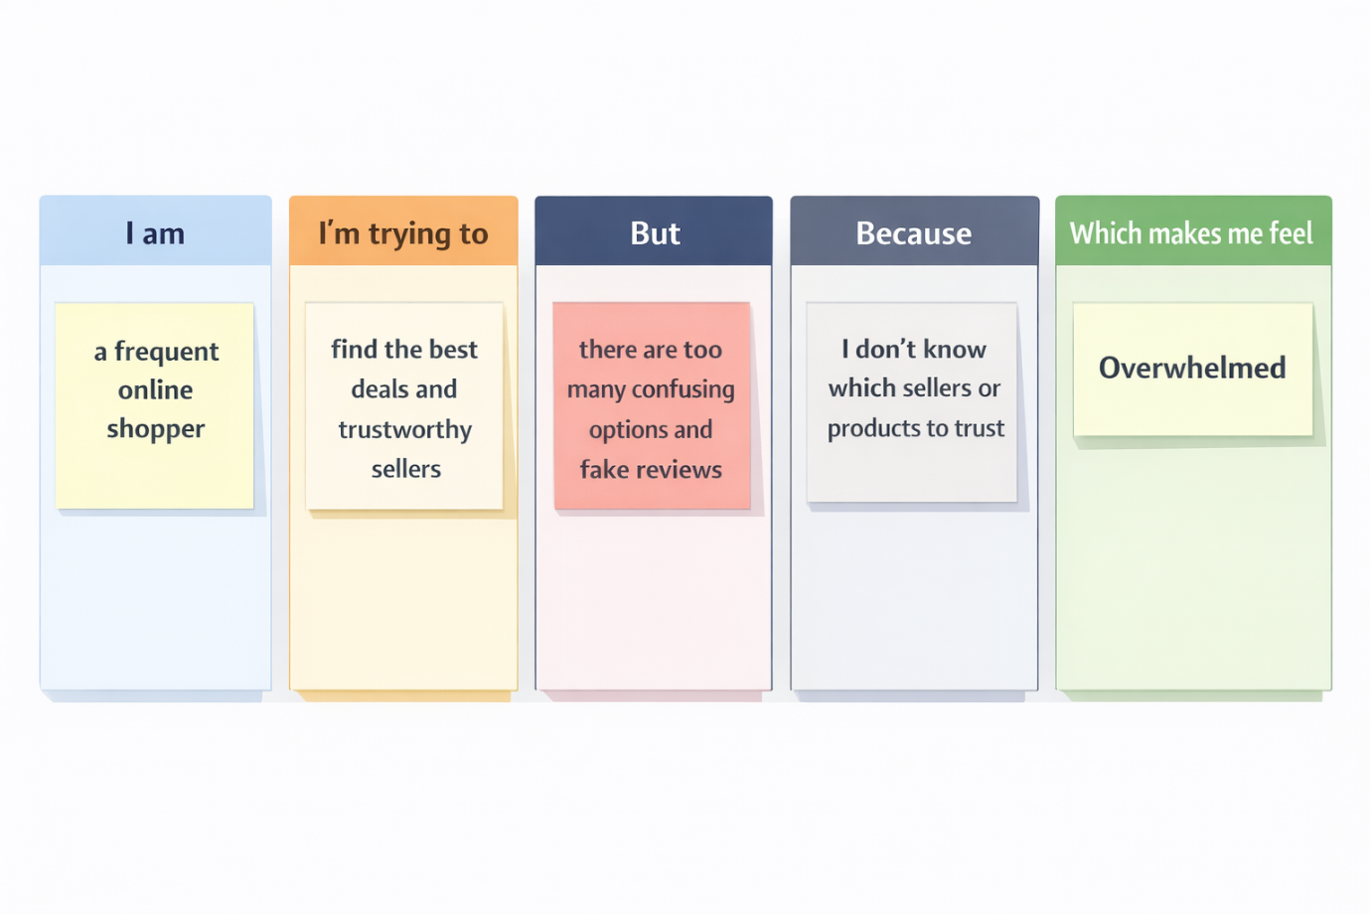

Problem Statement (PS) | I am (Customer/Seller) | I’m trying to | But | Because | Which makes me feel
PS-1 | A busy professional | Buy products quickly after work | I struggle to find reliable sellers open late | Many platforms don’t show seller availability | Frustrated and tired
PS-2 | A budget-conscious student | Get affordable products delivered fast | I can’t easily compare prices and delivery | Some sites hide extra charges until checkout | Confused and disappointed
PS-3 | A regular online shopper | Reorder my favorite items easily | I have to search again every time | Previous orders are not clearly saved | Annoyed and inconvenienced
PS-4 | A small business seller | Manage my products and orders efficiently | I don’t have a simple dashboard to update items or track sales | Existing systems are complex and not user-friendly | Overwhelmed and stressed
PS-5 | A customer placing an order | Pay securely and confidently | I worry about payment failures or fraud | Not all platforms provide clear payment verification | Anxious and uncertain
PS-6 | A customer awaiting delivery | Track my order in real time | I don’t know the exact delivery status | Some systems don’t update order progress properly | Impatient and worried

